**PARTICIPANT INFORMATION SHEET**

**WM Net Zero: A Health-Centred Systems Approach towards Net-Zero: Transforming regional climate mitigation policies**

**Understanding impacts of home energy saving improvements on indoor air quality**

Delivered in partnership with Dudley Metropolitan Borough Council Home Improvement Team, 4 Ednam Road, Dudley, DY1 1HL

**What is the purpose of the study?**

Climate change affects us all and it is important we take action to reduce Greenhouse Gas Emissions. In the WM Net Zero study we are studying how home energy saving improvements impact the quality of air we breathe indoors. The quality of air we breathe at home is important because we spend about 90% of our lives indoors and some pollutants and damp can affect our health and wellbeing.

We want to learn how indoor air quality, temperature and damp in your home change over time, especially when you make home energy saving improvements. We are studying this by measuring air pollution, temperature and moisture levels inside two groups of homes; those making home energy saving improvements and those that are not. By comparing the results from these two groups, we aim to understand how energy-saving improvements affect home environments and what this means for our health and wellbeing. Our findings will guide future home energy-saving schemes and the creation of healthier homes across the West Midlands.

**What will we ask you to do?**

As a resident living in the West Midlands we are inviting you to take part in this study.

If you take part, we will provide one or more small, quiet air quality sensors to place in your home for up to two years. These sensors measure air pollution, temperature and moisture levels in your home. The sensors are about the size of a book and use a small amount of electricity – costing about 30 pence each month (less than £5 each year). The sensors connect to your home Wifi so that our study team can collect information without needing to visit your home. We will only visit your home if the sensor(s) stops working properly. At the end of the study we will collect the sensor(s).

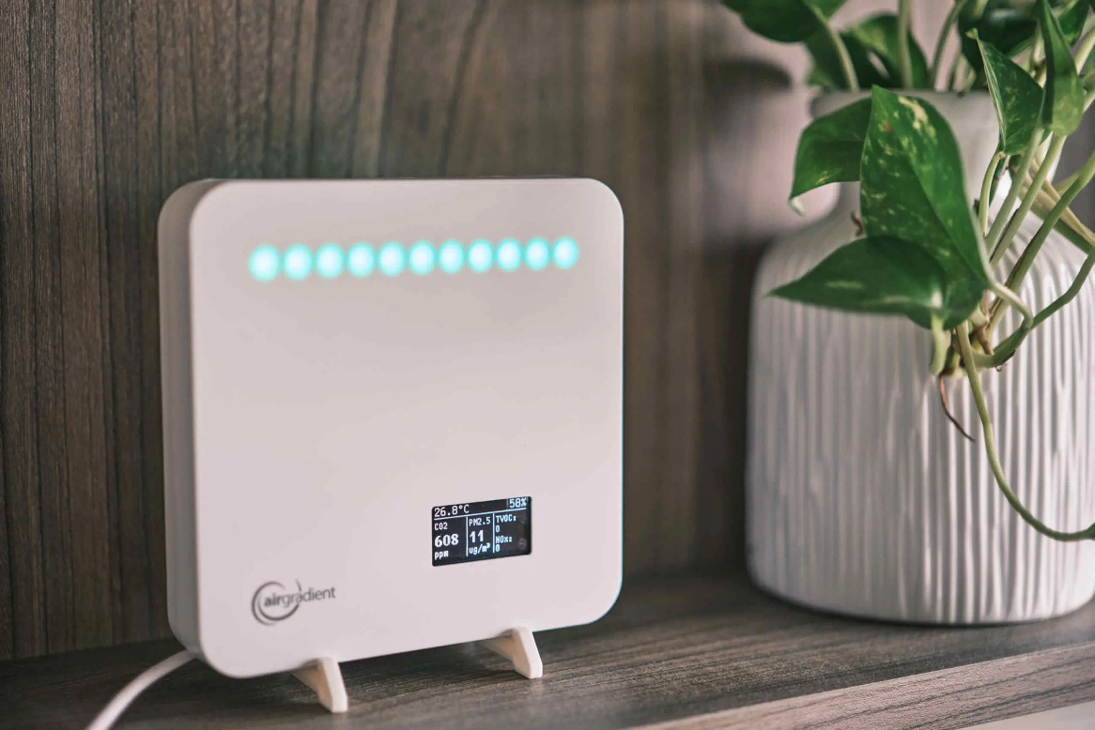

Picture shows AirGradient ONE sensor used in this study next to a pot plant

**What data will we collect?**

We will use the air quality sensors to measure small particles in the air (PM2.5), carbon dioxide (a greenhouse gas), organic chemicals like those from cleaning products or paints (Volatile Organic Compounds), as well as temperature and moisture (humidity) levels in your home. We will also ask you to complete a questionnaire about your home including questions about home appliances, energy usage, and behaviours in your home. The questionnaire will take up to 20 minutes to complete.

**What are the benefits and risks of taking part?**

**Benefits of taking part:**

* Gain insights into the quality of your home environment, air pollution, moisture and temperature.
* Receive practical advice on how to improve indoor air quality and reduce damp to make your home healthier.
* Receive a £25 Amazon voucher for each sensor hosted in your home.
* Contribute to important research that helps us understand home environments and shapes future climate actions.

**There are no expected risks of taking part in this study.**

**What will we do with your information?**

All data collected will be anonymised so that no personal information is linked to the findings. Your personal and household details will be securely stored and accessible only to the study team. Consent forms will be stored in a locked cabinet, and electronic data will be kept on the University of Birmingham’s secure server for up to 10 years before being deleted. Your identity will not be disclosed in any findings shared or published from the study.

**Who else is taking part?**

We are recruiting up to 50 people living in the Dudley Metropolitan Borough Council area to take part in this study. This includes people living in homes that will and will not receive home energy saving improvements, allowing us to compare how air quality, temperature, and moisture levels change over time in both groups.

**What happens at the end of the study?**

At the end of the study, we will share a summary of the findings with you and your local community. The results will also be shared with our project partners and published in scientific journals, as well as on our website: <https://wm-netzero.org.uk>.

**What if I have any more questions?**

If you have any questions or concerns, you can contact the WM-Net Zero study team:

* By post: Professor Zongbo Shi, Geography Earth and Environmental Sciences, University of Birmingham, Edgbaston, Birmingham, B15 2TT
* By email: [wm-netzero@contacts.bham.ac.uk](mailto:wm-netzero@contacts.bham.ac.uk).

**Our study team are here to help before, during, or after the study.**

**What if I change my mind?**

Participation is voluntary and you can withdraw at any time during the study by contacting us by letter or email without giving a reason. If you choose to withdraw before the study end (September 2026), we will ask for your permission to use the data you’ve already provided until the date of withdrawal. If you after data has been published it will not be possible to identify your household data to withdraw it. If you withdraw, we will collect the sensor within 2 weeks of notifying us of your decision.

**Who has reviewed the study?**

The study has been reviewed and approved by the University of Birmingham Science, Technology, Engineering and Mathematics (STEM) Research Ethics Committee [ERN_1825-Dec2023] to protect your safety, rights, wellbeing and dignity.

**Thank you for considering taking part in this study.**